**Castelazo - Application Controller Pattern**

The application controller is used to centralize the logic at one point to permit an easy maintenance and a central logic point. The application controller pattern is the pattern that permits the centralization of all view logic and promotes a unique process to define the flow. You use this so that you can prevent duplicating the same code in different parts of the program. Instead, the needed code is written once, and then it can be used by different views. This is useful because if you need to make changes to a piece of logic, you only need to do it in one spot, and that change is implemented to all parts of the program that need it.

This is done by placing all the flow logic in an Application Controller. Input controllers then ask the Application Controller for the appropriate commands for execution against a model and the correct view to use depending on the application context.

As you can see in the code example, in the file called GabeControl.java, I created the ***saveGame()*** code which is used to save the game. Since this can be implemented throughout the game from different views, it is best to use it in the application controller so that it does not need to be copied in multiple places of the program. The code for ***loadGame()*** is used in the beginning, but again, ***printReport()*** can be used in various places.

Enabling Java Web option in Netbeans.

1. Open Netbeans IDE
2. Click on TOOLS
3. Click on PLUGINS
4. Click on AVAILABLE PLUGINS
5. Type JAVA EE
6. Select **Java EE Base** checkbox
7. Click INSTALL
8. Follow prompts. Netbeans will need to be restarted after installation.

Start the Project

If GlassFish server not installed, the “Add Server Instance” dialog box will open.

1. Select an installation location
2. Select LOCAL DOMAIN
3. Accept license agreement
4. Click DOWNLOAD NOW… button

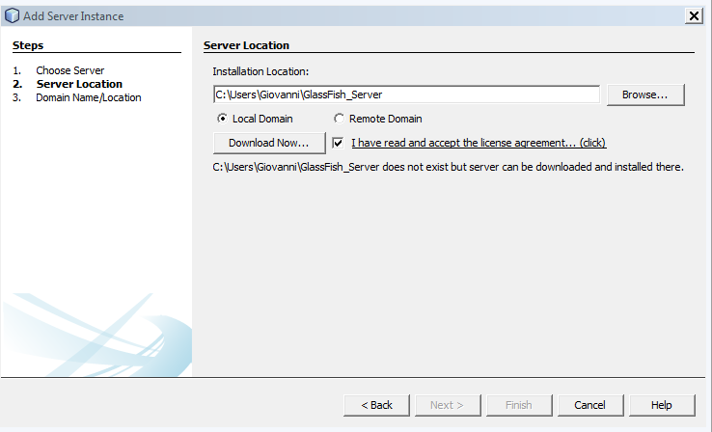

1. Choose a server to download and click OK. (I selected GlassFish Server 4.1.1)

